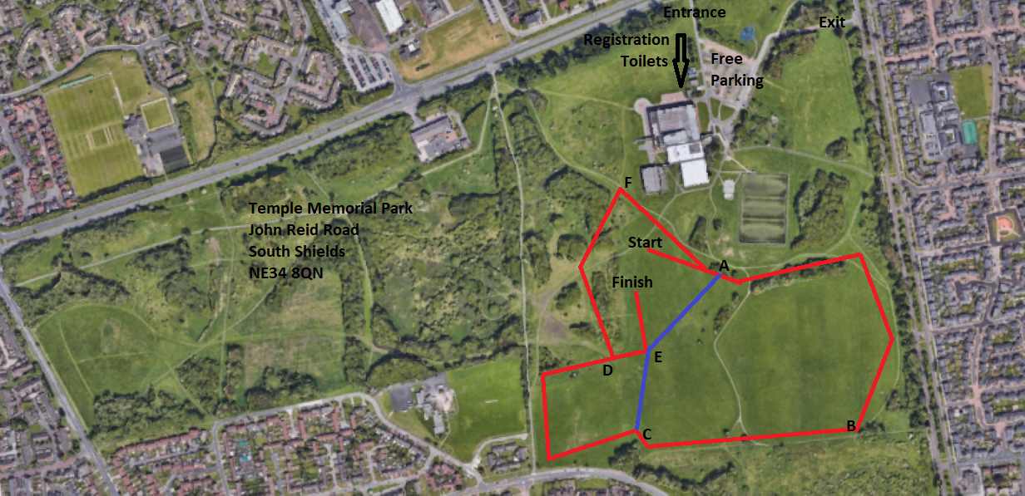
10 October2023 ESAA Schools’ Cross Country Cup – Round 1 / NSAA YEAR 7 RACES  10.45am – Junior Girls (2100m, small + large loop) Start-A-E-D-F-A-B-C-D-E-Finish  11.00am – Junior Boys (3200m, 2 large loops) Start-A-B-C-D-F-A-B-C-D-E-Finish  11.15am – Inter Girls (3200m, 2 large loops) Start-A-B-C-D-F-A-B-C-D-E-Finish  11.30am – Senior Girls (3200m, 2 large loops) Start-A-B-C-D-F-A-B-C-D-E-Finish  11.50pm – Inter Boys (4800m,3 large) Start-A-B-C-D-F-A-B-C-D-F-A-B-C-D-E-Finish  12.10pm – Senior Boys (4800m, 3 large) Start-A-B-C-D-F-A-B-C-D-F-A-B-C-D-E-Finish  12.30pm – Year 7 Girls (2100m, small + large loop) Start-A-E-D-F-A-B-C-D-E-Finish  12.45pm – Year 7 Boys (3200m, 2 large loops) Start-A-B-C-D-F-A-B-C-D-E-Finish | NSAA Primary Schools’ Team Cross Country Championships – 1.00pm Start  1.00pm – Year 3 Girls ( 1350m, 1 medium loop ) Start - A – B – C – E - Finish  1.15pm – Year 3 Boys ( 1350m, 1 medium loop ) Start - A – B – C – E - Finish  1.30pm – Year 4 Girls ( 1350m, 1 medium loop ) Start - A – B – C – E - Finish  1.45pm – Year 4 Boys ( 1350m, 1 medium loop ) Start - A – B – C – E - Finish  2.00pm – Year 5 Girls ( 1600m, 1 larger loop ) Start - A – B – C – D - E - Finish  2.15pm – Year 5 Boys ( 1600m, 1 larger loop ) Start - A – B – C – D - E - Finish  2.30pm – Year 6 Girls ( 1600m, 1 larger loop ) Start - A – B – C – D - E - Finish  2.45pm – Year 6 Boys ( 1600m, 1 larger loop ) Start - A – B – C – D - E - Finish

